OCTANET – WEB DEV INTERN

# TASK -1 REPORT NAME: S. MADHURI

**EMAIL .ID:**

# [sakhamurimadhuri2002@gmail.com](mailto:ravillapranathi23@gmail.com)

**Task Title**: Creating a Landing Page for this Course Introduction

## Task Description:

The goal of this project is to design and develop a compelling landing page to introduce an online course on web development. The landing page should effectively communicate the value proposition of the course, engage potential students, and encourage them to enroll.

## Steps:

A course introduction landing page serves as a gateway to attract potential students and provide them with essential information about the course. Here's an outline of what such a landing page might include**:**

1. **Course Title and Overview:** Clearly state the title of the course and provide a brief overview of what it covers. This section should succinctly communicate the main topics or objectives of the course.
2. **Instructor Information:** Introduce the instructor(s) who will be leading the course. Include their credentials, experience, and any relevant expertise that establishes their authority in the subject matter.
3. **Key Features and Benefits**: Highlight the unique features and benefits of the course. This could include information about the format (e.g., video lectures, interactive quizzes), access to resources (e.g., readings, case studies), and any additional perks (e.g., certification, access to online communities).
4. **Course Curriculum:** Provide an outline of the course curriculum, including the topics covered in each module or lesson. This helps potential students understand the structure and depth of the course content**.**
5. **Testimonials or Reviews:** Showcase testimonials from past students or industry professionals who have taken the course. Positive feedback and endorsements can help build trust and credibility with prospective students**.**
6. **Enrollment Information**: Clearly outline the enrollment process, including any prerequisites, registration deadlines, and payment options. Make it easy for visitors to take the next steps to enroll in the course.
7. **FAQs:** Anticipate common questions that prospective students may have about the course and provide clear answers to address any concerns or uncertainties they may have**.**
8. **Call-to-Action (CTA):** Include a prominent CTA button or form prompting visitors to enroll in the course or sign up for more information. Make sure the CTA stands out and is easy to find on the page.

Overall, a course introduction landing page should effectively communicate the value of the course, establish trust with potential students, and encourage them to take action to further explore or enroll in the course.

## Challenges Faced:

In a project like creating a course introduction landing page, several challenges might arise. Here are some common challenges you might face:

1. **Design Consistency**: Ensuring consistent design elements across different sections of the landing page can be challenging, especially when incorporating various visuals, text, and interactive elements.
2. **Responsive Design**: Making the landing page look and function well on different devices and screen sizes requires careful planning and testing to ensure a seamless user experience across desktops, tablets, and smartphones.
3. **Content Clarity**: Communicating the course's value proposition and key information concisely and effectively can be challenging, especially when balancing the need for detail with the desire to keep the page visually appealing and engaging.

## SCOPE:

The scope and functions of a course introduction landing page can vary based on the specific requirements and goals of the project. Here's an overview of the typical scope you might include:

1. **Design**: Create a visually appealing and user-friendly layout for the landing page that reflects the brand identity of the course and provides a positive user experience.
2. **Content**: Develop concise and compelling content that communicates the value proposition of the course, including information about course objectives, curriculum, instructors, and enrollment details.
3. **Interactivity**: Implement interactive elements and functionality to engage visitors and encourage them to explore further or take action, such as enrollment or signing up for updates.
4. **Responsiveness:** Ensure the landing page is responsive and

accessible across a variety of devices and screen sizes, including desktops, laptops, tablets, and smartphones.

1. **Performance:** Optimize the performance of the landing page to ensure fast loading times and smooth user interactions, even under varying network conditions.

## Interactivity and Functionality:

Discuss the JavaScript code used to add interactivity and functionality to the landing page. Explain the purpose of each JavaScript function or event handler and how it enhances the user experience.

Include any additional features or enhancements implemented, such as smooth scrolling, form validation, or dynamic content generation**.**

## Reference design & code:

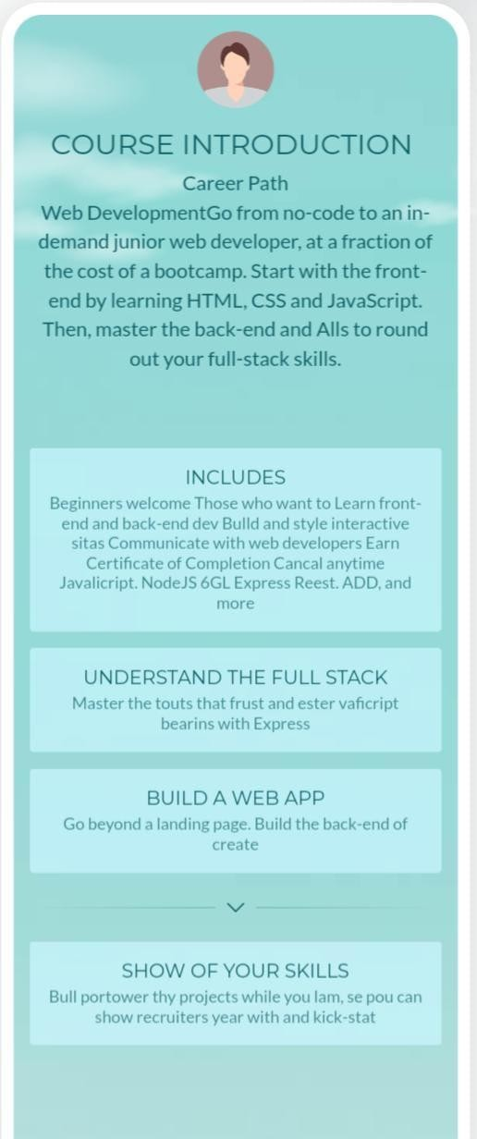

**<!**DOCTYPE html>

<html lang="en">

<head>

<meta charset="UTF-8">

<meta name="viewport" content="width=device-width, initial-scale=1.0">

<title>Course Introduction Landing Page</title>

<link rel="stylesheet" href="styles.css">

</head>

<body>

<header>

<h1>Welcome to Our Course</h1>

<p>Learn and Grow with Us!</p>

</header>

<section class="course-info">

<h2>About the Course</h2>

<p>This course covers a range of topics including HTML, CSS, and JavaScript.

It is designed for beginners who want to learn web development.</p>

<ul>

<li>Duration: 8 weeks</li>

<li>Format: Online</li>

<li>Price: $99</li>

</ul>

<a href="#enrollment" class="cta-button">Enroll Now</a>

</section>

<section id="instructor" class="instructor-info">

<h2>About the Instructor</h2>

<img src="instructor.jpg" alt="Instructor Photo">

<h3>John Doe</h3>

<p>John is a seasoned web developer with over 10 years of experience. He is passionate about teaching and helping others learn.</p>

</section>

<section id="enrollment" class="enrollment-info">

<h2>Enrollment</h2>

<p>Ready to get started? Enroll now to secure your spot!</p>

<form id="enrollment-form" action="enroll.php" method="POST">

<input type="text" id="name" name="name" placeholder="Your Name" required>

<input type="email" id="email" name="email" placeholder="Your Email" required>

<button type="submit">Enroll</button>

</form>

</section>

<footer>

<p>&copy; 2024 Course Introduction Landing Page</p>

</footer>

<script>

// Smooth scrolling to section when clicking on CTA button document.querySelector('.cta-button').addEventListener('click', function(e) { e.preventDefault();

const targetSection = document.querySelector(this.getAttribute('href')); targetSection.scrollIntoView ({ behavior : 'smooth' });

});

</script>

</body>

</html>

## Conclusion:

In conclusion, the key findings and outcomes of the project. Reflect on the challenges faced, lessons learned, and areas for improvement in future iterations.

## Future Enchancements:

Outline potential future enhancements or features that could be added to further improve the landing page. Consider feedback from users or stakeholders and prioritize enhancements based on their impact and feasibility.

## References:

List any **external resources, tutorials, or frameworks** used in the project. Include links to relevant documentation or sources for further reference.